DR. NDUBUISI M. NNANNA BIO

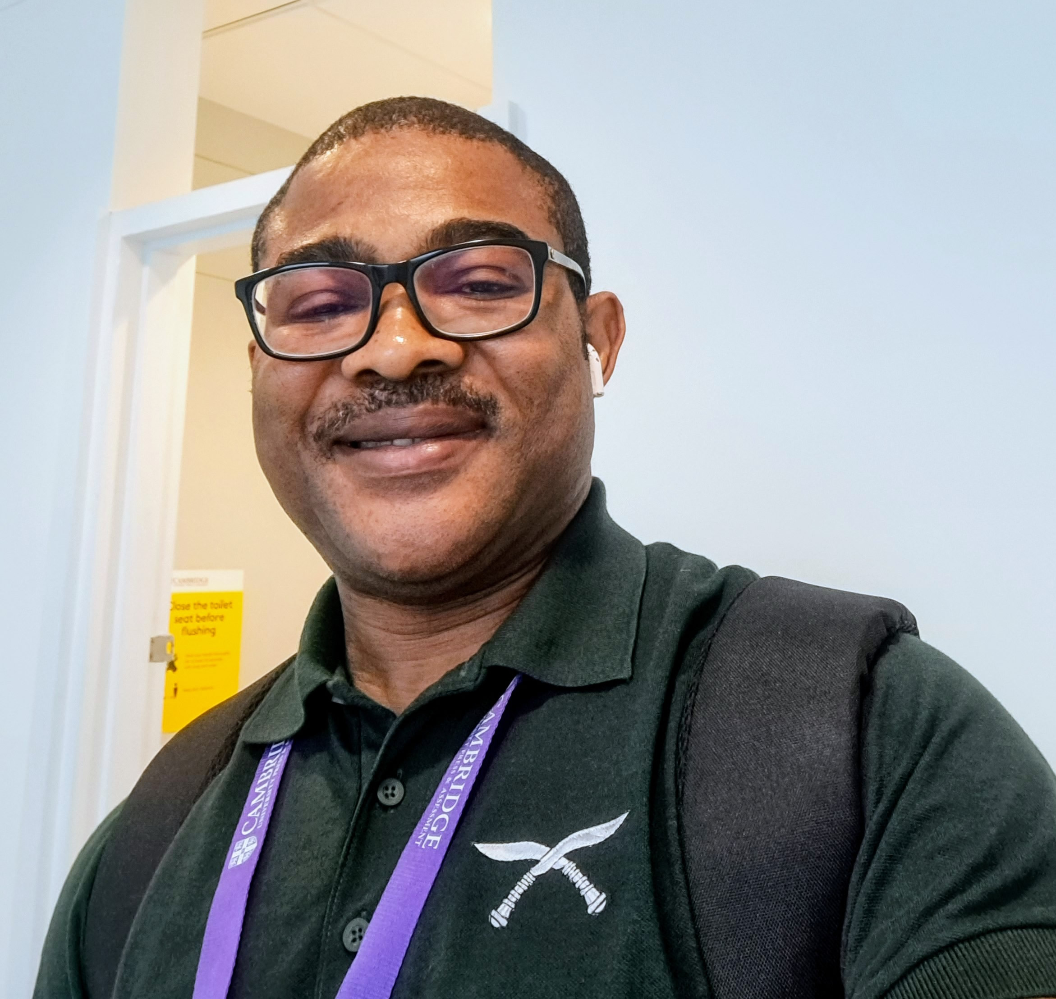Dr. Ndubuisi Nnanna is the Director of the Youth Friendly Resource Centre at the University of Nigeria Nsukka and a Senior Lecturer in the Department of Theatre and Film Studies at the same university. He is a Fellow of the Ife Institute of Advanced Studies, holds the Global Arts in Medicine Fellowship, and is an alumnus of the University of East Anglia in the United Kingdom, where he earned a Master's degree in Film, Television & Creative Practice. His research interests include Film and Media Studies, Gender and Development Media, Youth & Children’s Theatre, Media & Migration Studies, Acting and Directing, African Drama and Theatre, and Post-Colonial Drama. His publications primarily cover these fields. Currently, he is interested in the role of media in women's development within rural communities and displaced populations, as well as the use of drama and theatre therapy for the care of the elderly and individuals with physical and mental challenges. He is enthusiastic about collaboration on research projects related to these areas.

Dr. Nnanna has worked with and consulted for several governmental and non-governmental organisations on the use of culture and performing arts for community and human development. These organisations include UNICEF, DfID, African Cultural Centre, Women’s Aid Collective, Brassland Africa Network, and the National Council for Arts and Culture. He has directed more than 30 large-cast play productions and acted in more than 50 in a performance career spanning more than two decades. Nnanna is keenly interested in the value of diversity and inclusion for intercultural integration and has presented papers at several international and local conferences and published in reputable journals globally. He is the author of two plays: Luscinia (2020) and Song of the Owl (1998), both of which dramatize the challenges faced by self-motivated women in a male-dominated society in transition.
Ndubuisi Nnanna’s domiciliary status as an African living in Africa, his membership of multidisciplinary professional bodies such as the International Literacy Association, African Theatre Association, Society for Cinema and Media Studies, the International Health Humanities Network and his passion for African culture as part of a vibrant global culture and civilized humanity has positioned him as an informed source of information on African culture and performance.

Ndubuisi Nnanna is currently the Executive Director of the Nigerian-based Development Performance Initiative and the African Art Consult. He is also a Director of the Campus Action Against Sexual Harassment.

Mobile: +234 803 868 4409, +234 809 945 1839
Email: ndubuisi.nnanna@unn.edu.ng, director.youthfriendlycentre@unn.edu.ng

